
MARATHWADA MITRA MANDAL’S
COLLEGE OF COMMERCE
Affiliated to Savitribai Phule Pune University, Re-Accredited by NAAC
ISO 9001:2015 Certified, Awarded as Best College by Savitribai Phule Pune University.
202/A, Deccan Gymkhana, Pune – 411004
principal@mmcc.edu.in, enquiry@mmcc.edu.in, www.mmcc.edu.in
_______________________________________________________________________________________

Department of Business Administration
Report on Industrial Visit to Sant Tukaram Sahakari Sakhar Karkhana Ltd.
- Event Name: Industrial Visit to Sant Tukaram Sahakari Sakhar Karkhana Ltd.
- Organized by: Department of Business Administration
- Day and Date: Saturday, 10th January 2026
- Venue: Sant Tukaram Sahakari Sakhar Karkhana Ltd.,
Mulshi, Taluka Mulshi,
District Pune, Maharashtra.
- Objectives of the Visit:
- To provide students with practical exposure to the functioning of a cooperative sugar manufacturing unit.
- To understand the end-to-end sugar production process from sugarcane procurement to finished goods.
- To study operational management, quality control, and safety practices followed in the sugar industry.
- To familiarize students with cooperative management structure and rural-based industrial operations.
- To bridge the gap between theoretical concepts and real-life industrial practices.
- Audience:
The visit was organised for student of TY BBA and BBA-IB.

- Number of Participants:
A total of 100 students along with 4 faculties visited the industry.

- Brief description of the event:
The Department of Business Administration organised an industrial visit to Sant Tukaram Sahakari Sakhar Karkhana Ltd., Mulshi, one of the prominent cooperative sugar factories in Pune district. The visit aimed at providing students with first-hand exposure to large-scale manufacturing operations and cooperative industrial management.

Upon arrival at the factory premises, students were welcomed by the factory officials, who gave an introductory briefing about the history, growth, and contribution of Sant Tukaram Sugar Factory to the rural economy. The officials explained the cooperative model, membership structure, and the role of farmers in the management of the sugar factory. Students were then taken on a guided tour of the manufacturing unit. They observed the complete sugar manufacturing process, including sugarcane weighing, crushing, juice extraction, clarification, evaporation, crystallization, centrifugation, and packaging. Emphasis was laid on the efficient utilization of by-products such as bagasse and molasses. The visit also highlighted quality control mechanisms, safety measures, and environmental practices adopted by the factory. Students gained insights into power generation through cogeneration plants and water management practices followed in the sugar industry.
An interactive session with the factory personnel enabled students to ask questions related to production challenges, seasonal operations, pricing policies, government regulations, and employment opportunities in the sugar sector. The visit proved to be highly informative and enriching.

- Learning Outcome:
- Students gained a clear understanding of the sugar manufacturing process.
- The visit enhanced their knowledge of cooperative management and rural-based industries.
- Students understood the importance of quality control, safety, and sustainability in manufacturing.
- The exposure helped students relate classroom learning with real-world industrial operations.
- The visit fostered interest in agro-based and cooperative industries.

- Photographs:
Students along with faculty members at Sant Tukaram Sahakari Sakhar Karkhana Ltd.

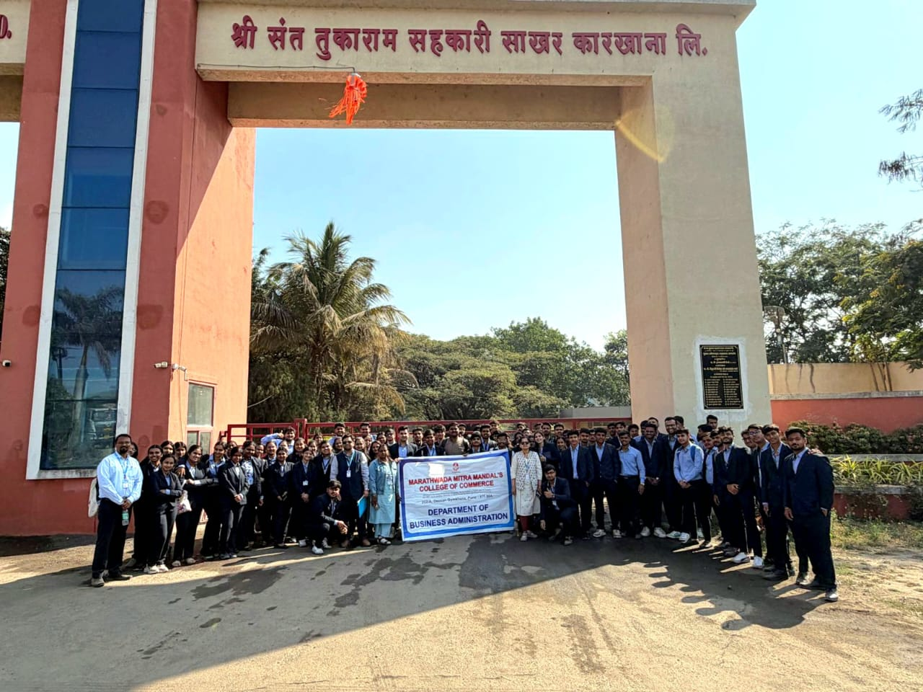

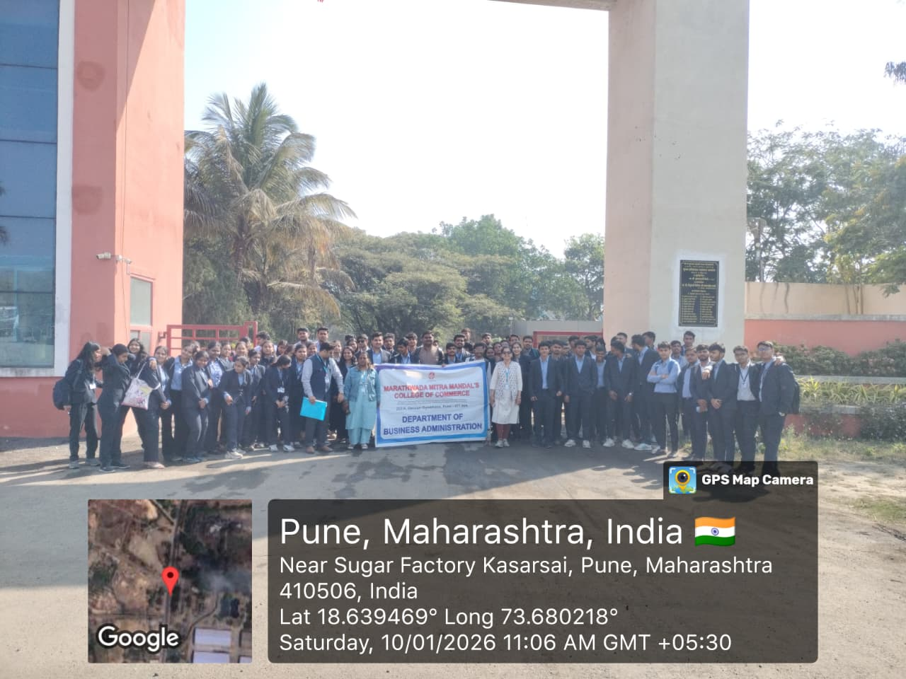

Students along with faculty members at Sant Tukaram Sahakari Sakhar Karkhana Ltd. -Geotagged photograph

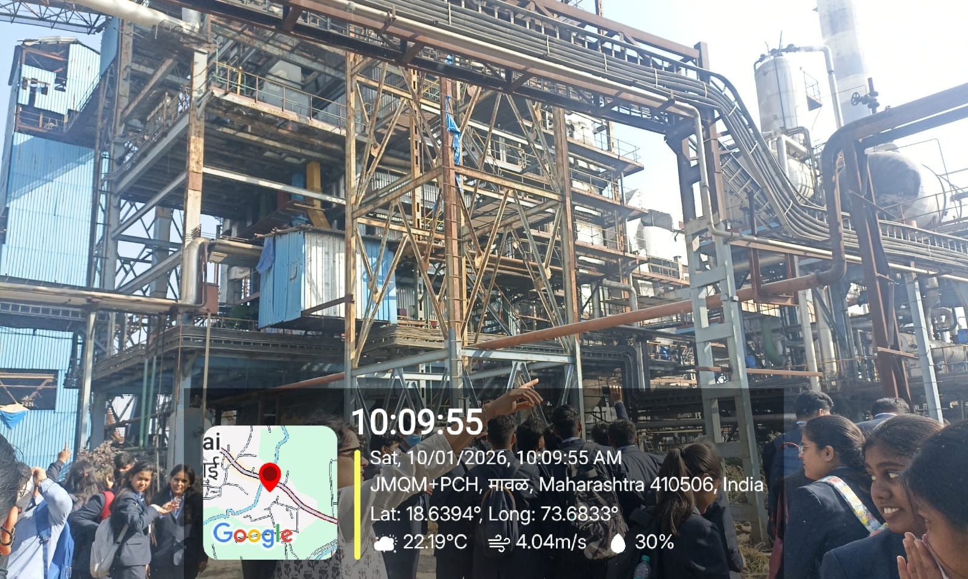
Students along with faculty members at the sugar manufacturing unit.

12. Acknowledgement:
The Department of Business Administration expresses its sincere gratitude to Principal Dr. Kishor Nikam for permitting and supporting the visit. Dr. Ganesh Patare for his visionary guidance and motivation Head of Department, Dr. Gurmeet Kaur Rajpal, for her guidance and efforts in coordinating the activity and all faculty members for their efforts and smooth organisation along with the non-teaching staff for maintaining the discipline and order during the visit.

Prepared By: Verified By:

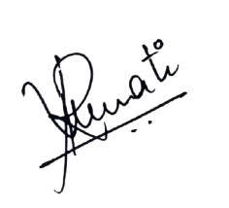

Asst. Prof. Reshma Awati Dr. Gurmeet Kaur Rajpal
Event In-Charge Head of Department

Authorized By:



Dr. Ganesh Patare Dr. Kishor Nikam
Academic Coordinator Principal

